1,logn,n,nlogn,n2,n3,2n

Linear search o(n)

BinarySearch o(logN)

template <class TYPE>

int BinarySearch(const vector<TYPE>& arr, const TYPE& key){

int retval=-1;

int low=0;

int high=arr.size()-1;

int mid;

while(low<=high && retval==-1){

mid=(low+high)/2;

if(arr[mid] > key)

high=mid-1;

else if(arr[mid] < key)

high= mid+1;

else

retval=i;

}/*while*/

return retval;}

Recusrive

int Fact(int x){

int result; //stores result of function

if(x==1 || x==0) //check for base case

result=1; //if x is 1 or 0 result is 1

else //else it is recursive case

result=x * Fact(x-1); //result is x * (x-1)!

return result;}

Findones

int FindOnes(int N){

int result;

if(N==1) result=1;

else if(N==0) result=0;

else{

if(N%2==1) result=FindOnes(N/2)+1;

Else result=FindOnes(N/2);}

return result;}

The advantage of a doubly linked list
- No need to search entire list to find previous pointer
- Can move/search in both directions on list
- can access entire list from any point

the disadvantages of a doubly linked list
- more memory is needed to store back pointer
- requires more work to set up back links properly

Advantages of a circular linked list
- Some problems are circular and a circular data structure would be more natural when used to represent it
- The entire list can be traversed starting from any node (traverse means visit every node just once)
- fewer special cases when coding(all nodes have a node before and after it)

Disadvantages of a circular linked list
- Depending on implementation, inserting at start of list would require doing a search for the last node which could be expensive.
- Finding end of list and loop control is harder (no NULL's to mark beginning and end)
- goprev()

if(curr_!=start_){

Node* temp=start_; //step 1

while(temp->next_!=curr_) temp=temp->next_; //step 2

curr_=temp;}

InsertBefore()

Node* pr=prev(); //step 1

Node* temp=new Node; //step 2

temp->data_=newdata; //step 2

temp->next_=curr_; //step 2

pr->next_=temp; //step 3

curr_=temp; //step 4

Stack(push,pop,initialize,empty,full)(postfix,bracketchecking)

------------------------------------------------

int FindOnesNR(int N){

int result=0;

Stack<int> mystack;

while(N>=1){

if(N%2)

mystack.push(1);

N=N/2;

}

while(!mystack.isempty()){

result+=mystack.pop();

}

return result;}

Queue(insert,remove,init,empty,full,front)(networkprinter,graphtheory)linkedlist,o(1),o(n),circullarll o(1)

algorithm for resizing.:

oldsize=queue.size(); //will be start of end of list

queue.resize(); //make it bigger

if(end<front){

oldend=end; //keep track of where the oldend value is

end=oldsize; //this is where numbers will begin insertion.

for(int i=0;i<oldend;i++){

queue[(oldsize+i)%queue.size()]=queue[i];

}

Quicko(nlogn),o(n2)
- Pick a value from the array as the pivot
- Let i=front, j= back
- advance i until you find a value arr[i] > pivot
- move j towards front of array until arr[j] < pivot
- swap these arr[i] and arr[j].
- repeat step 3 to 5 until i and j meet
- The meeting point is used to break the array up into two pieces
- QuickSort these two new arrays

The idea of a quicksort is that with each call, the quicksort algorithm would break the vector up into two parts. The best thing that can happen is that each time we get pieces that are of equal size

The worst thing that can happen for the quicksort algorithm is to choose a pivot such that we end up getting a pivot point that breaks up the vector into an empty vector and a vector containing everything else every single time

The median is the number where half of the other numbers are below it and half the other numbers are above it

Bubble,o(n2)

Logic:

start at the beginning of the array and swap adjacent elements that are not in order. Repeat this n-1 times

-------------------

template <class TYPE>

void BubbleSort(vector<TYPE>& arr){

TYPE tmp; /*used for swapping*/

int i;

int j;

for (i=0; i<arr.size()-1; i++) {

for (j=0; j<arr.size()-1-i; j++){

if (arr[j+1] < arr[j]) { /* compare the two neighbors */

tmp = arr[j]; /* swap a[j] and a[j+1] */

arr[j] = arr[j+1];

arr[j+1] = tmp;

Enqueue is easy just call:

gostart();

insertBefore(val);

Dequeue is easy to call:

goend();

insertAfter(val);

Insertion o(n2)

by looking at the array as if it is being filled in. The idea is that the array starts off in the first iteration as if it has only one element in it. The numbers that come after are then inserted into the "array" at the correct position. This is continued until all values in the entire array have been properly "inserted"

---------------------------------------------------

template <class TYPE>

void InsertionSort(vector<TYPE>& arr){

TYPE curr;

int i, j;

for(i=1;i<arr.size();i++){

curr=arr[i];

for(j=i;j>0 && arr[j-1] > curr;j--){

arr[j]=arr[j-1];

}

arr[j]=curr;

}

----------------------------------------------------

Heapsort()

To Heap Sort we build Heap O(NlogN) then destroy the Heap O(NlogN). Therefore the whole sorting algorithm has a runtime of O(NlogN)
- put every value in the array into the binary heap, then repeated call Delete_Min to remove the smallest value and put it back into the array

Binary Heap - A binary heap is a complete binary tree where the heap order property is always maintained.

Binary Tree - A binary tree is either
- empty (no nodes), or
- contains a root node with two children which are both binary trees.

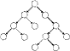

Complete Binary Tree - A binary tree where there are no missing nodes in all but the bottom level. At the bottom level the missing nodes must be to the right of all other nodes.

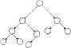

-------------------------------------------------------

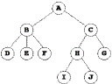

Chaining

At every spot in your hash table store a linked list of items

Less wasted space, no overflow

the runtimes depends on l. The average length of each chain is λ. λ is the number of expected probes needed for either an insertion or an unsuccessful search. For a successful search it is 1+λ/2 probes.

Linear Probing

If a given position is already being used, then search the list for the next available open space

The problem that this creates is that the items in hash tables tend to create clusters. Any attempt to hash a value into the cluster would cause the item to be placed in an alternate spot and increase the size of the cluster.

Average number of probes in an unsuccessful search using linear probing is around:

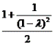

Average number of probes for a successful search using linear probing is around:

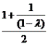

Quadratic Probing

similar to Linear probing.

The difference is that if you were to try to insert into a space that is filled you would first check 12=1 element away then 22 = 4 elements away, then 32 =9 elements away then 42=16 elements away and so on.

In order to guarantee that your quadratic probes will hit every single available spots eventually, your table size must meet these requirements:
- Be a prime number
- never be more than half full (even by one element)

Double Hashing

Whenever a collision occurs, choose another spot in table to put the value. The difference here is that instead of choosing next opening, a second hash function is used to determine the location of the next spot

Mergeo(nlogn)

If you have 2 arrays that are already sorted, then you can "merge" them into a single sorted array by choosing to add the smaller of the "next" item between the two arrays.

template <class TYPE>

void Merge(vector<TYPE>& arr, vector<TYPE>& tmp, int start,

int start2, int end){

int aptr=start;

int bptr=start2;

int i=start;

while(aptr<start2 && bptr <= end){

if(arr[aptr]<arr[bptr])

tmp[i++]=arr[aptr++];

else

tmp[i++]=arr[bptr++];

}

while(aptr<start2){

tmp[i++]=arr[aptr++];

}

while(bptr<=end){

tmp[i++]=arr[bptr++];

}

for(i=start;i<=end;i++){

arr[i]=tmp[i];

}

}

template <class TYPE>

void MergeSort(vector<TYPE>& arr){

vector<TYPE> tmp(arr.size());

MergeSort(arr,tmp,0,arr.size()-1);}

--------------------------------------

One reason is that each node needs two extra pointers so for small data the memory needed for the pointers could easily exceed that of the data. Also, we really don't need the linking structure because our tree is a complete binary tree

Suppose data was stored in element i.

The left child of that node is in element 2i+1

The right child of the node is in element 2i+2

The parent of the node is stored in (i-1)/2 (for all but root node)

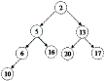

-------

Heap Order Property: The values in the children of each node must be bigger than that in the node

Insert: first left then right on each level

Delete-min:

. In order for the binary tree property to be maintained we will be removing the right most node at the bottom level

The empty spot that had been created by the removal of the value at root must be filled and the value that had been in the rightmost node must go back into the heap

A complete binary tree with N nodes means that at most there are log N nodes from the root (top) to a leaf (a node at the bottom of the tree)

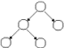

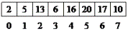

Tables

A table is an unordered collection of items. Each item in the table has a unique key. A hash table uses the key to directly calculate its location in an array structure. To do this the key is passed into a hash function which returns an index.

A good hash function should be:

Uniform (all indexes are equally likely for a given key)

Random (not predictable)

Root Node the top most node from which all other nodes come from. Note that all nodes can be considered root node of their subtree.

Ex. A is the root of the entire tree. B is the root of the subtree containing B,D,E and F

Leaf Node A node with no subtrees

Ex. D,E,F,I,J,and G are all leaf nodes

Child: Root node of a subtree of a node is the child node

Ex. B is the child of A. I is the child of H

Parent : Opposite of a child node

Ex. A is parent of B. H is the parent of I

Siblings: All nodes that have the same parent node are siblings

Ex. E and F are siblings of D but H is not

Ancestor: All nodes that can be reached by moving only in an upward direction in the tree.

Ex. C, A and H are all ancestors of I but G and B are not.

Descendants of a node are nodes that can be reached by only going down in the tree.

Ex. Descendents of C are G,H,I and J

Levels: Nodes in Level 0 of our tree is A. Nodes in Level 1 are B and C, Nodes in Level 2 are D,E,F,G and H. Nodes in Level 3 are I and J

Height: number of levels in the tree (in our case 4)

Path: Set of branches taken to connect an ancestor of a node to the node. Usually described by the set of nodes encountered along the path.

Loadfactor:

The measurement of fullness is called the Load Factor.

λ = number of items in list/size of list

if λ = 0.5 it would mean that 50% of the table is full
- Bucketing

Make every entry in the array big enough to hold N items (N is not amount of data. Just a constant). Think of it as a 2-D array.

Problems:
- Lots of wasted space.If N is exceeded, another strategy will need to be used.Not good for memory based algorithm but doable if buckets are disk-based

For a hash table of M hash entries and X buckets:

Successful Search - O(X) worst case

Unsuccessful Search - O(X) worst case

Insertion - O(X) - assuming success, bucketing does not have good way to handle non-successful insertions.

Deletion - O(X)

Storage: O(M * X)

Binary tree: A binary tree is a tree where every node has 2 subtrees that are also binary trees. The subtrees may be empty.

Not a tree:

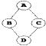

Insert B. Must go on left as B < D

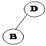

Insert C. C < D so look at left subtree. C > B so go on right branch from B

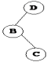

Insert E. E > D. D's right subtree is empty so put E there.

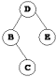

In order traversal:

This means all values less than the current node are first dealt with, then the current node then the nodes with values greater than the current node

-------------------

void PrintNode(TNode<TYPE>* node){

if(node){

PrintNode(node->left_);

node->data_.print();

PrintNode(node->right_);

}

}

void Print(BST& tree){

PrintNode(tree.root_);

}

PreOrder traversal, the current node is visited first then the children are visited (left first then right)

node->data_.print();

PrePrintNode(node->left_);

PrePrintNode(node->right_);

Post Order traversal, the children are visited first and then the current node is visited

Delete

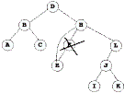

Delete with two subtree

To delete B, we must:

1) find its inorder successor (next biggest value).

done by going right then go left as far as possible

2) promote inorder successor to replace node to be deleted

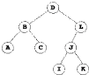

A binary search tree is a binary tree where all values in left subtree < value in current node < values in right subtree

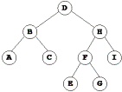

In order successor of B is C. Delete node containing C and replace data in node B with data in node C

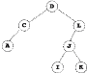

Traversal

Depth first
- Preorder

- Process current node
- Then the left sub tree
- Then the right sub tree

- In order (they will give u the data in order , from small to big)

- Process left sub tree
- Process current node
- Process the right sub tree

- Post order

- Process left sub tree
- Process right sub tree
- Process current node

Breath first

Top to button

Left to right

Remove for nodes with two sub trees

Find the in order descendent

And add it to tree

In order successor can have only one child

In order successor can't have a left child

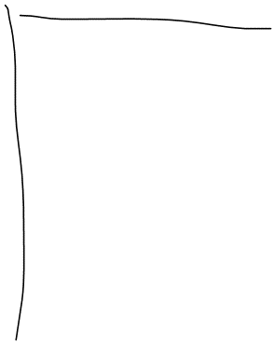

Hash table file

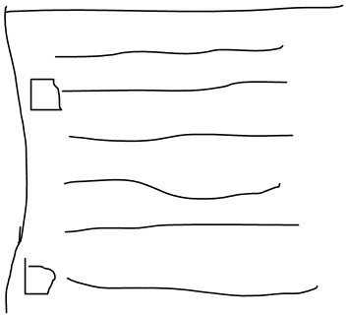

Prepare

It should go to every entry and checks to see if the entry is empty or full

And flags the empty slots (what is flagging ? )

// open the file with the file name passed in as an argument

//if the file does not exist

Create a new file to be used by hash table

Set the number of hash items to zero

Prepare it for hash table {

You have to count the number of hash items in the file to determine the occupied capacity

}

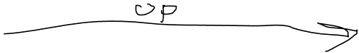



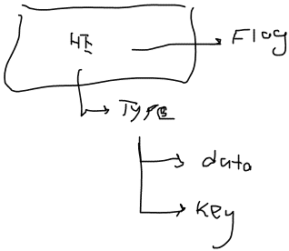

Sizeof(hashEntry)

For getting the size of hash table . We loop through the file till EOF

Reading each hash entry

When u open a file for the first time , u have to fill it with empty hash item objects to the amount of capacity

BST::~BST(){

DestroyTree(root_);

}

Void BST::DestroyTree(Node*& subtreeroot)

{

If (subtreeroot){

DestroyTree(subtreeroot->left);

DestroyTree(subtreeroot->right);

Delete subtreeroot;

subtreeroot = null;

}

}

Height : number of nodes from the root to the furthest leaf inclusive

Balance : perfectly balanced tree : number of nodes in left and right subtree differ by one node more that one for all subtrees

Can reach any node in o(log n)

Slow to maintain

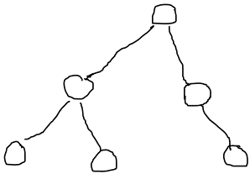

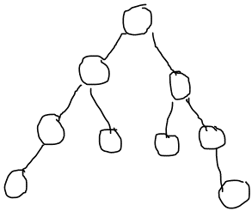

Height balance: height of left and right subtrees differ by no more than one

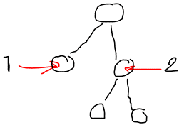

Height balanced

Binary trees that are height balanced are called AVL trees

Should maintain this balance after all the operations

To do this each node keeps track of the height balance of that node. This is calculated as follows : height right - height left

You don’t have to worry about any node's height balance aside from the ones u traversed through to get to the destination node .

Of any node has a height balance of two or more it does not have height balance

If height balance is >=2 or <= 2 ……> do rotation

Nodes must have a height balance of 0 or one

Rotation will fix it.

- Think about find method

- Send the key to hash function , get the index , go to index in file . If the key is equal to the key passed , holder = rec_ ; (what happens if the record is not there , should I look for other locations to the end of file ? Linear probing)
- Seekg(0) , use a while loop to ftable.eof() , if any key == key . Holder = rec_;

- Think about update method

If (Find(data.key())){

Seekp(tellg());

Write , the update item

}else{

Index = Hash(data.key());

Ftable.Seekg (0);

Ftable.seekg(Index * sizeof(permHashEntry));

Ftable.read(reinterpret_cast<const char *>(&item), sizeof(permHashEntry));

If (item.isempty) {

Write the new item

}else{

???? Move till u find another empty slot and enter the item there (move to the end , and then from beginning to current spot)

If (Found the spot){

Seekp(the spot)

Enter the new item there

Ftable.write(reinterpret_cast<const char *>(&item), sizeof(permHashEntry))

}else{

Return false

}

}

}

- Think about remove method
  - Send the key to find method if found , remove (what do u mean by remove , just rec_ = Null and isempty = true ? ) (after found , seekp(tellg()), then write)

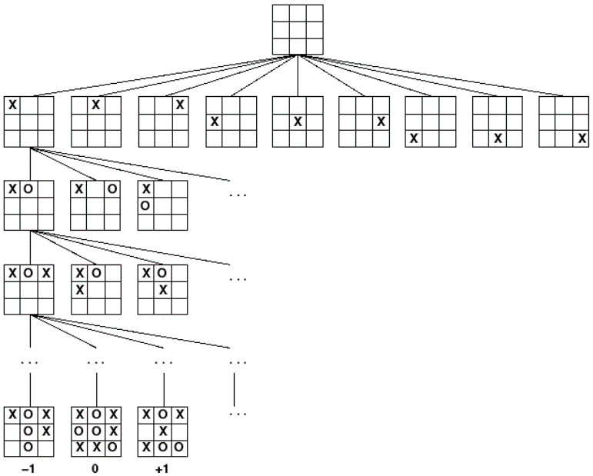

You go certain levels down , and after a certain level u evaluate it :

- U score it , (the representing number for score has to be more than zero which stands for losing and say 100 the number for winning)
- So your evaluation function will come back with a number , lets say u compare the number of critical masses ready to explode between u and your opponent

If you are at a node with even level . The score should be the maximum , because u are the one who is going to make a move

If you are at a node with odd level , the score should be the least

- Nodes are either leaf nodes or have exactly 2 or 3 children
- A node with two children has one value
- A node with tree children has 2 values
- All leaf nodes are always at the same level

A node with 2 children

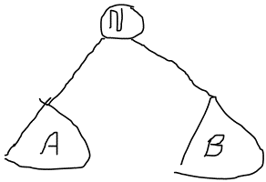

A and B are 2-3- tree

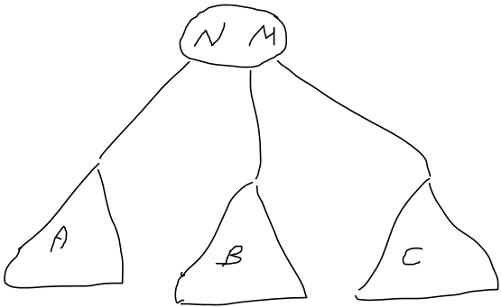

All nodes in A < N< all nodes in B

How to insert:

Do not create a new node when inserting
- Find the leaf node where value belongs
- If the leaf node has one value add the node to that nodes
- If the leaf node has two values , promote the median value to the parent and split node into two
- If the node being split was the root node a new root is created

All the nodes in A < n < all the nodes in B < m < all the nodes in C

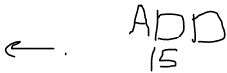

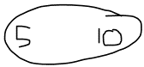

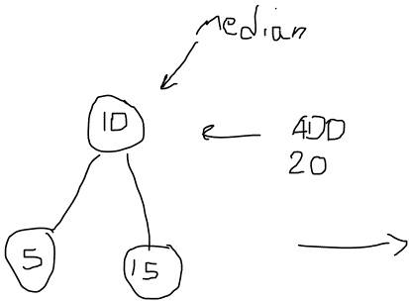

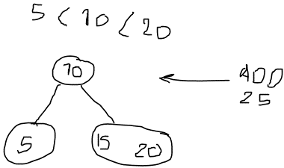

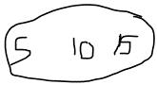

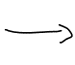

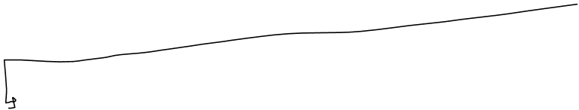

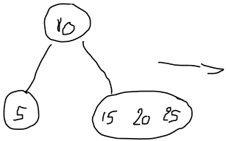

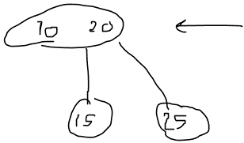

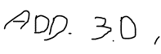





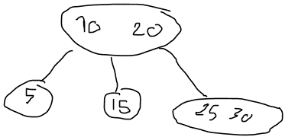

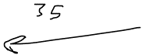

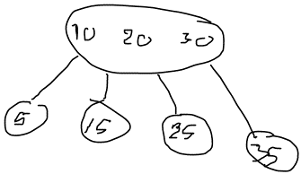

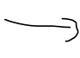

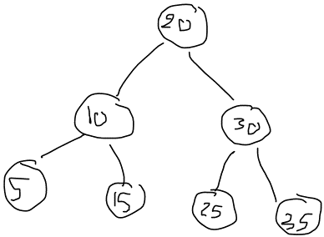

When removing values from a 2-3 tree u always remove them from the leaf nodes

When u are removing a leaf node that has one value . U should look at the siblings , if u have a sibling with two values.

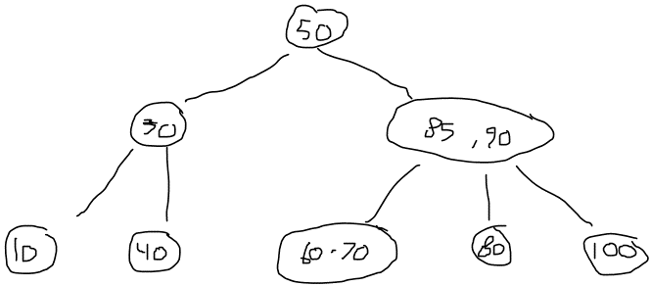

Delete 80

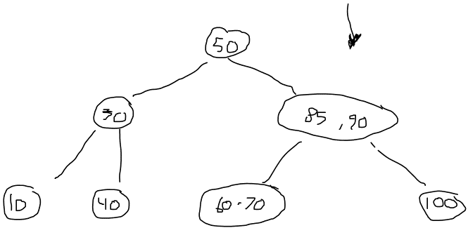



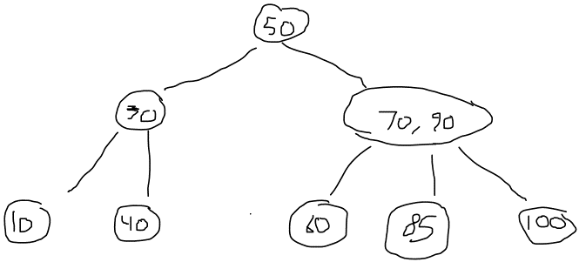

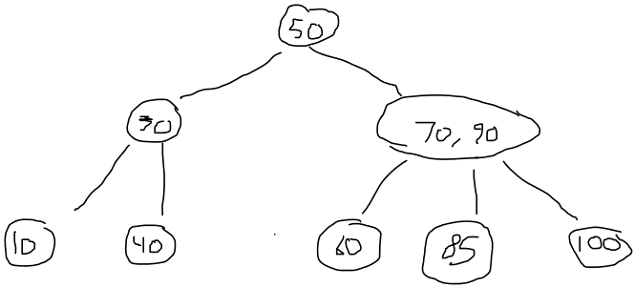

Remove 85

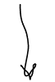

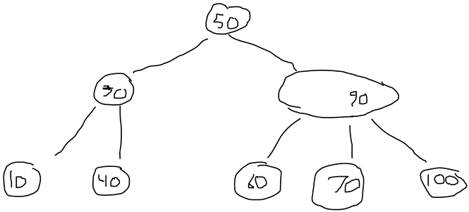

Http://slady.net/java/bt/

Google : b-tree animation applet

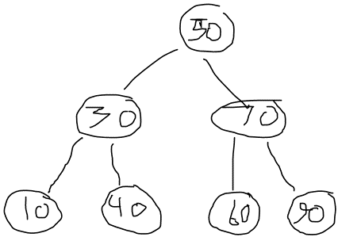

Remove 90



When u have just one value , and u have no siblings that have more than one value , what u do is to pull the parent down

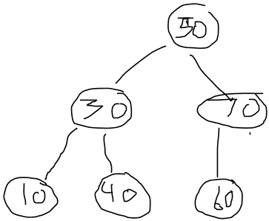

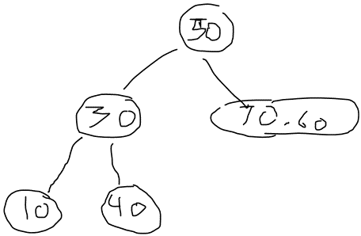

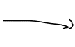

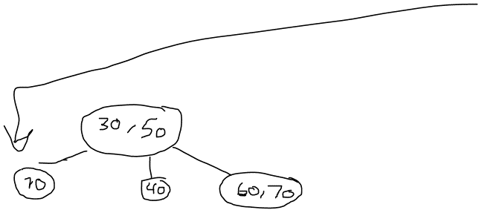

Apple

Applet

Apricot

banana

